Table of Contents
1
One Page GDD 2
Design Objective 2
User Persona Comparison 3
User Persona 3
The Game World 4
The Story 7
Game Design 9
Rules, Mechanics 9
System 11
UI & Screen Flow Design 11
References 14

One Page GDD
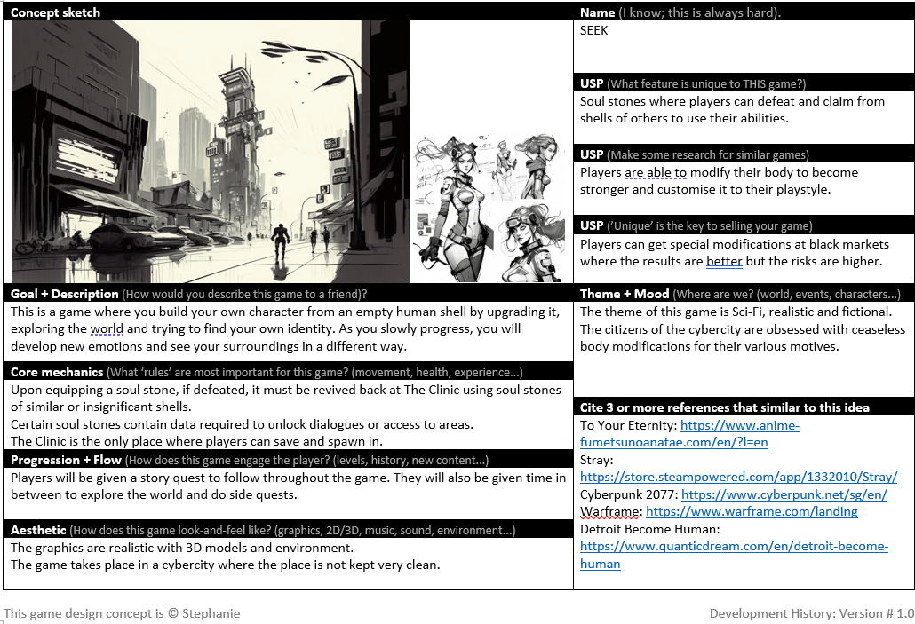

Design Objective
The design objective is to create a Sci-Fi game where players build their characters and story from a fresh new beginning. This is to allow players to be completely immersed into the story and characters.

User Persona Comparison
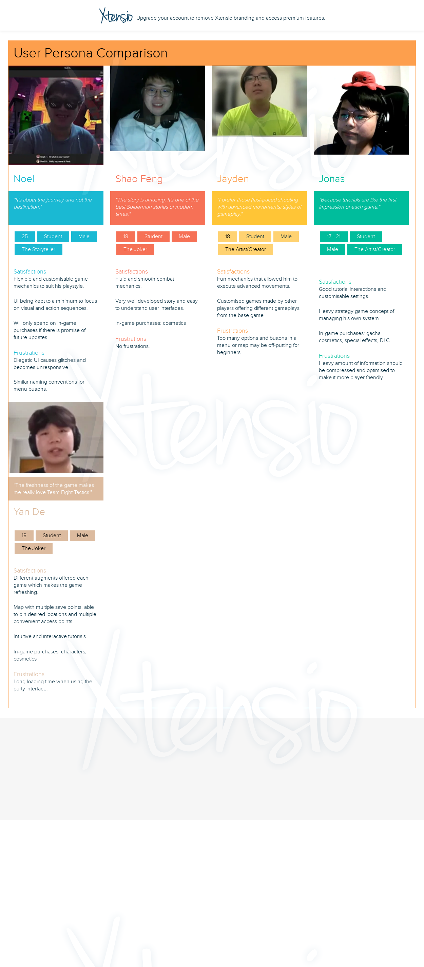

User Persona

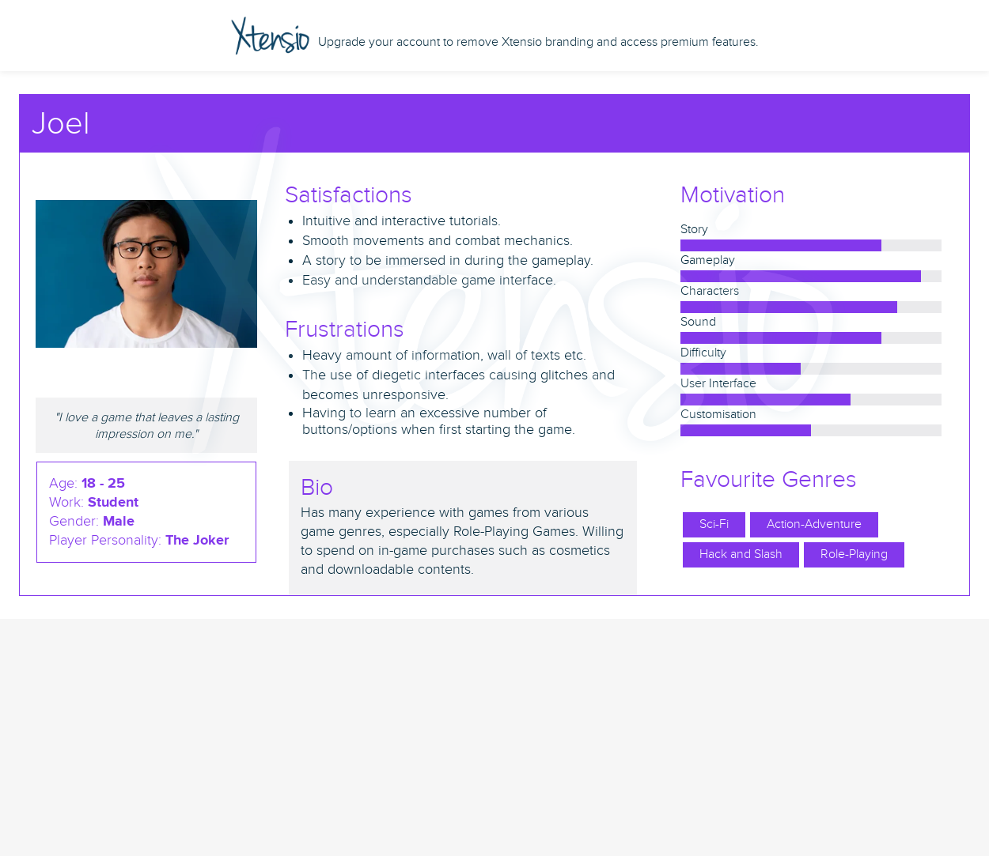

The Game World
The game is set in a cybercity where its citizens are obsessed with ceaseless body modifications for various motives. The player starts off in an alleyway and begins their adventure in search of their identity.
In the game, players can interact with various venues such as The Clinic, Black Market, Cosmetic and Pawn shops to do certain activities.
The overall aesthetics of the game feels very futuristic and dark. The background audio while player roam would be a calm and soft music, to make the players feel more relaxed exploring the world.
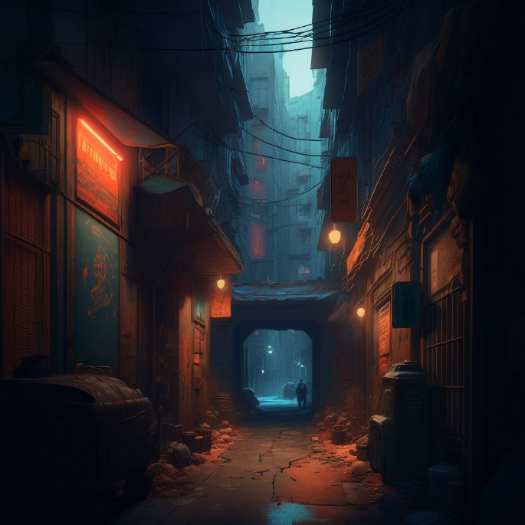
Figure 1 Cybercity Alleyway
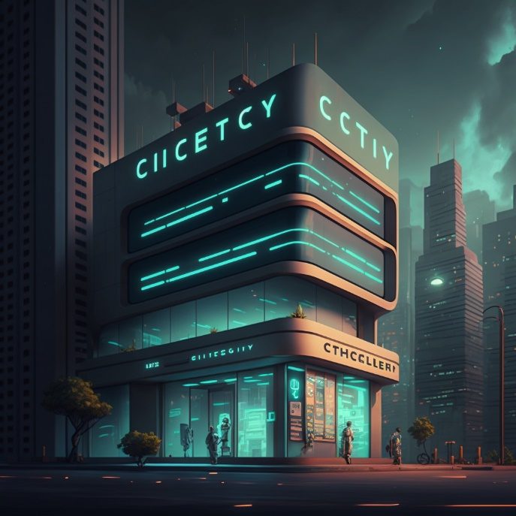
Figure 2 Cybercity Clinic
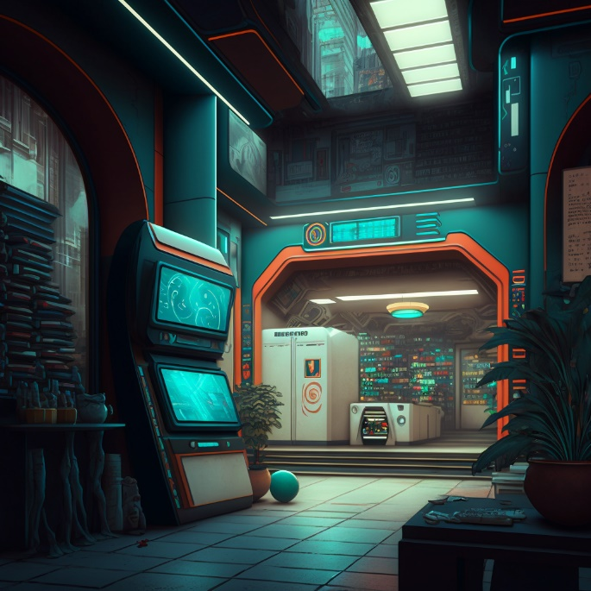
Figure 3 Cybercity Shop
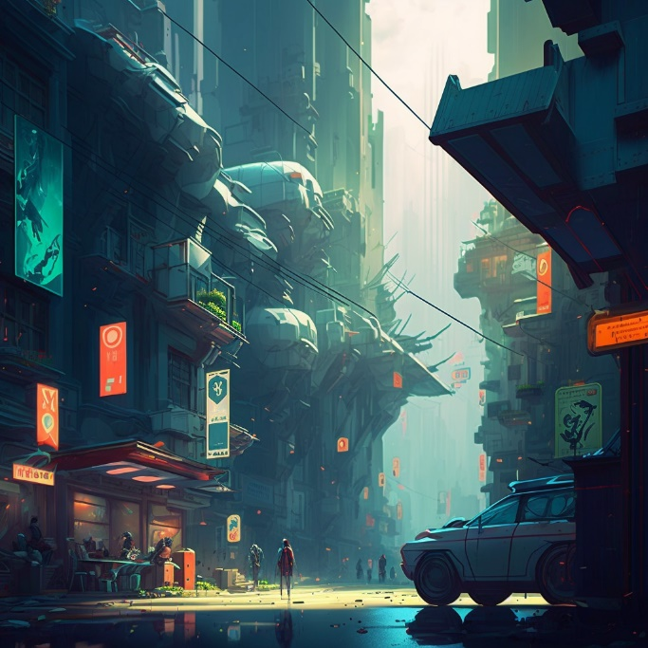
Figure 4 Cybercity Concept Art 1
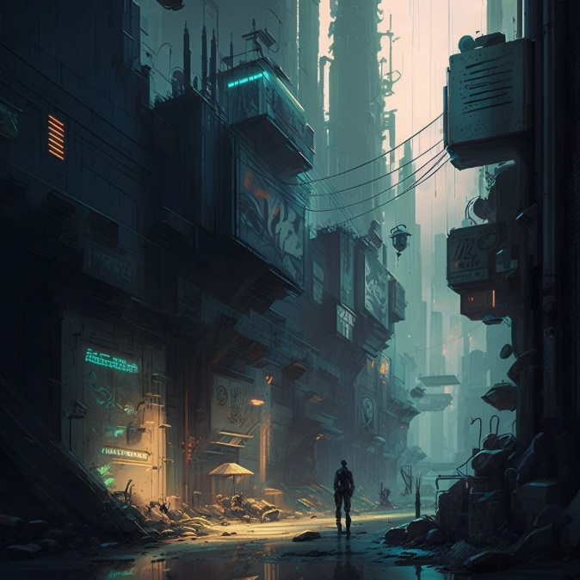
Figure 5 Cybercity Concept Art 2
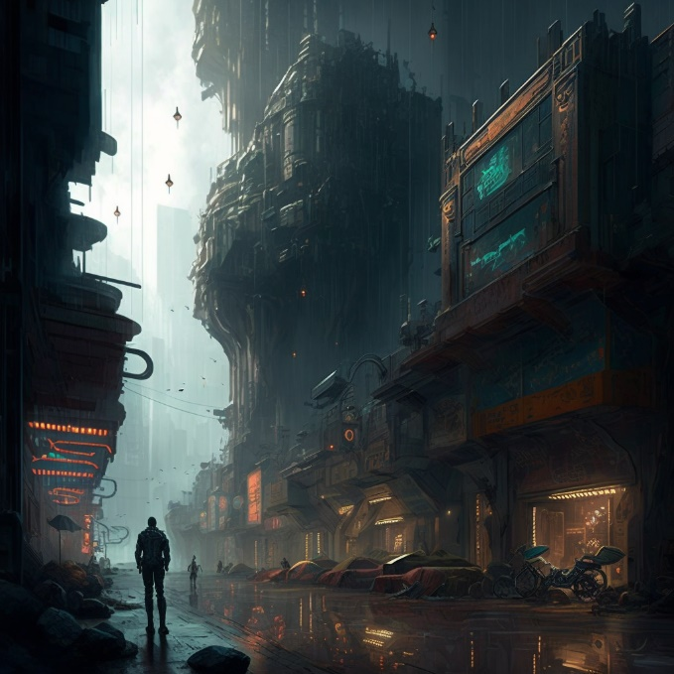
Figure 6 Cybercity Concept Art 3
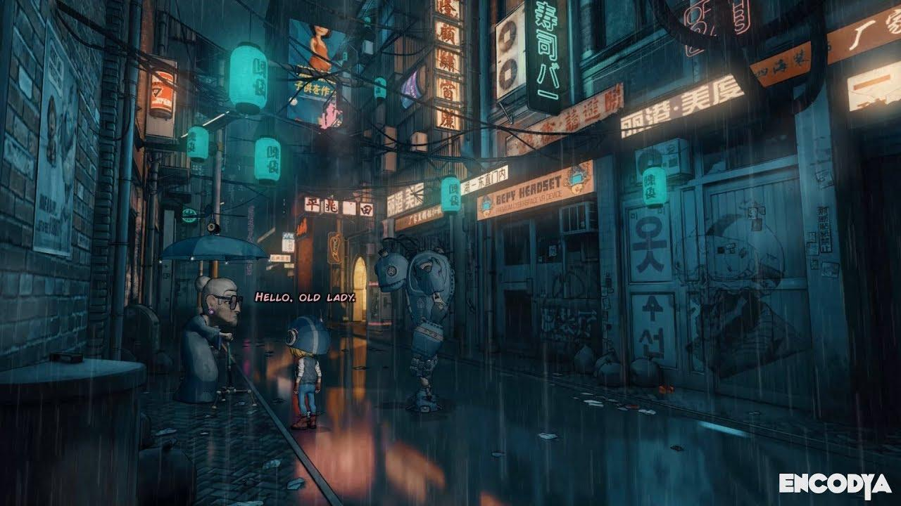
Figure 7 Cybercity Concept Art 4

The Story
Awakened in an alleyway of a cybercity, you, an empty human shell, must find your own identity. Wandering around the cybercity, you noticed different types of shells walking about. You then felt a hand tap the back of your head.

A strange man, who claimed to be 'a doctor', noticed your raw and organic human shell. He offered you a machine upgrade where it can enhance your senses and make advanced body modifications. He has always wanted to try out his invention but there were no organic human shells to try it on, not until you came along. With no knowledge on the cyber world, you complied. The doctor diagnosed that you were an empty human shell with no emotions, knowledge or pain receptors, showing his growing curiosity of where and how you came about.
After the successful operation, you had an upgraded weapon equipped inside of your forearm. When flexed, a sharp knife would pop out of your forearm.
You felt a warm feeling around your chest. Was it a happy emotion? Whatever it was, you wanted more. Seeing your reaction, the doctor gave you a list of raw materials needed for more upgrades that can only be obtained by killing dangerous creatures in parts of the cybercity.

Along with the doctor's guidance, you explored around the area in search of the creatures. Along your journey, you defeated several small mobs, gaining more combat experience and creature intel. After exploring and following clues from the gathered creature intel, you found your way to their hideout.

Using your combat experience and newly equipped weapon, you defeated the creature and obtained the materials you required. Along with it, you noticed a glowing stone at the heart of the creature. You reached out to it and upon contact, you sensed the overwhelming presence of the creature in the stone. The stone was calling out to you, tempting you to hold it closer to your beating heart.
You gave in to its temptations, hugging the stone tightly as the stone slowly embeds into your heart. You felt the overwhelming power and emotions of the creature within you as your organic human shell took the physical form of the mechanic creature.

The creature's overpowering hatred and greed were new emotions to you. Despite the overwhelming emotions, you were able to control your own will and remove the stone at any time, returning to your organic human shell. This newfound power of the stone led you to feel the same emotions as you had when you first had your forearm modified into a weapon. You seek and crave for more stones in order to experience more of these pleasurable emotions.
As you slowly made your way back to the doctor with the required materials, you wondered if the shells of your kind will also produce a similar stone when killed. Your thirst for more of these new emotions led you to killing the first shell that walked past you. You held the dropped stone close as it embeds into your heart. It was a new refreshing feeling - cold yet calm.
You grew more and more excited as you realise that all shells produce a stone when killed. You wanted to grow stronger so that you could defeat bigger and more powerful monsters, gaining a more pleasurable emotion.

You decided to head back to the doctor quickly to upgrade and modify your body. You provided the materials to the doctor as he worked on your body. Despite not all operations being successful, the successful ones were more than enough to continue hunting for more stones. You continued your journey of upgrading your body while you hunt for more stones throughout the cybercity.
Your mission to finding your own unique identity turned into a stone hunt for your own satisfaction. A bounty was placed on you and it became harder to roam freely about in the cybercity. Despite this, as time goes by, you managed to fulfil your goal of experiencing all stones in the cybercity, including the doctor's.

Despite fulfilling your goal, you felt an empty feeling in your heart. Throughout this journey, the emotions you felt did not belong to you. They were not genuine. This was what the doctor must have meant when he diagnosed that you did not possess any emotions. There was no stone in your heart to begin with.
You have achieved your goal, but at what cost? The only genuine feeling you ever had was when the doctor had first modified a weapon into your forearm. With the doctor gone, you started to feel lonely. It started to hit you hard that you had been alone all along, experiencing fake and stolen emotions of others.
Knowing that you needed to fix this, you decided to return all the stones back to their rightful owners. Rummaging through the doctor's notes, you managed to find a way to return them all - at the cost of a life.

The method was successful, bringing the cybercity back to its lively state. You opened your eyes in shock, not expecting to be alive. You took a good look at the mirror, only to realise you have taken the form of the doctor. The doctor had left a gift for you - his stone.

Game Design
Seek is a Sci-Fi, Role-Playing, Action-Adventure game which Hack and Slash combats where players can modify and upgrade armour and weapons onto their characters whenever they want in the game. They have to seek the world out and discover their own identity. As the player progresses, they will discover and feel new emotions which will affect the way they see the world.
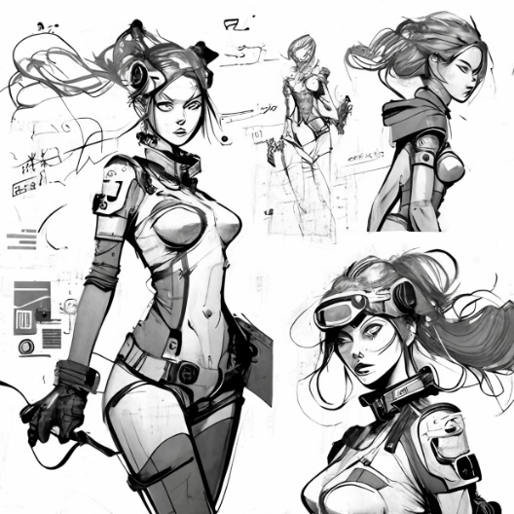
Figure 8 Example of Style for Human shells

Rules, Mechanics
*Highlighted unique elements (USP) or feature sets of the design.
Tutorial will guide the player around the world and teach players on the different interfaces along as they play. The doctor will be guiding the player around the cybercity. After the main tutorial, the player will receive a free modification by the doctor and be sent off to their first quest.
Player starts off with a naked human shell, at full Health Points (HP).
When the player is defeated, player will spawn back at the clinic.
Upon defeat, the player’s HP, as well as body modifications’ durability, will be reduced to half, requiring repairs.
The clinic is the only place that the players can save and respawn from.
Player does not possess a soul stone, unable to make certain decisions.
Combat
Combat is dependant and varies depending on the modifications of the player.
Varies depending on: Weight, type, special effects (e.g., Poison), etc.
Combat movements: Light attacks, heavy attacks, chain attacks, stealth attack, block, parry, dodge.
Soul Stone
Soul stones are dropped after defeating a shell.
Each unique soul stone collected unlocks a new playable character, equipping the players with its physical form and boosted statistics.
Depending on how the soul stone was obtained, statistics of soul stone varies (better statistics if killed stealthily etc.).
Collecting similar soul stones of same shell type serves as an upgrade for the respective shell.
Collecting soul stones opens more choices (dialogues, quests etc.) for the player.
New emotions will be felt and can affect their surroundings (secret paths, fake dialogues etc.).
Player can only hold up to 3 soul stones. The rest can be crushed up and used as materials back at the clinic.
Already upgraded shells will have higher statistics of material value if chosen to get crushed and replaced.
Playable characters who have been defeated upon equipped needs to be revived using soul stones of similar or insignificant shells.
Insignificant shells possess soul stones of low value.
Modifications
Players must gather materials and parts by themselves to modify or upgrade them.
Players must increase their experience points to unlock more powerful modifications.
Each modification and upgrade come with a risk and side effects.
Playable characters’ parts can be taken and modified onto the player’s original shell.
Quests
Players have to pick up side quests in order to afford modifications.
Multiple side quests can be accepted.
Map
Mini map will have waypoints for selected quest.
Map will display location of quests accepted for easy access.
Locations
Clinic The player’s home. A place where they spawn and get modifications from the doctor.
Black Market A hidden area in an alleyway of the cybercity where players can get special modifications at a discounted price, but at a higher risk and more dangerous side effects.
Cosmetic shops There will be cosmetic shops around the cybercity for places to purchase and customise their characters.
Pawn shops Players can sell unused materials or items in exchange for either money or items of equivalent value.

System
The game is developed for PC using Unity game engine. Before being developed, the game will have a low-fidelity and high-fidelity prototype to test its playability. This will help to get a good overall idea and feel of the game.

UI & Screen Flow Design

UI Design
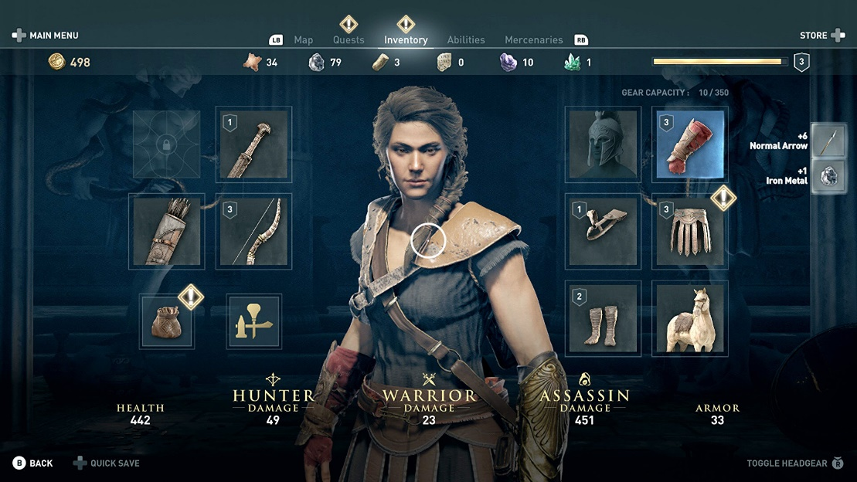
Figure 9 Inventory & Modifications UI Design
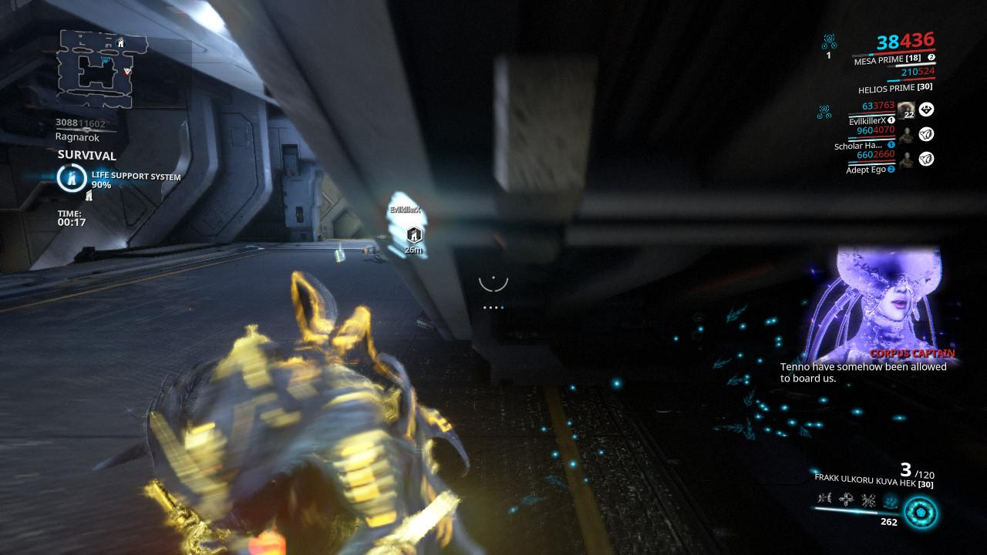
Figure 10 Tutorials given through a hologram UI
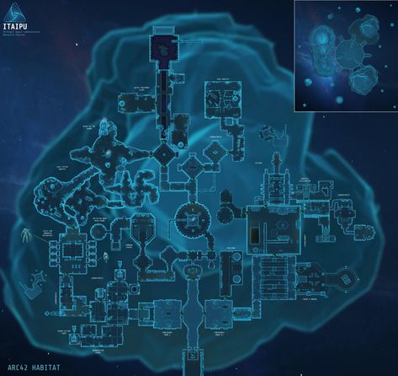
Figure 11 Map Design
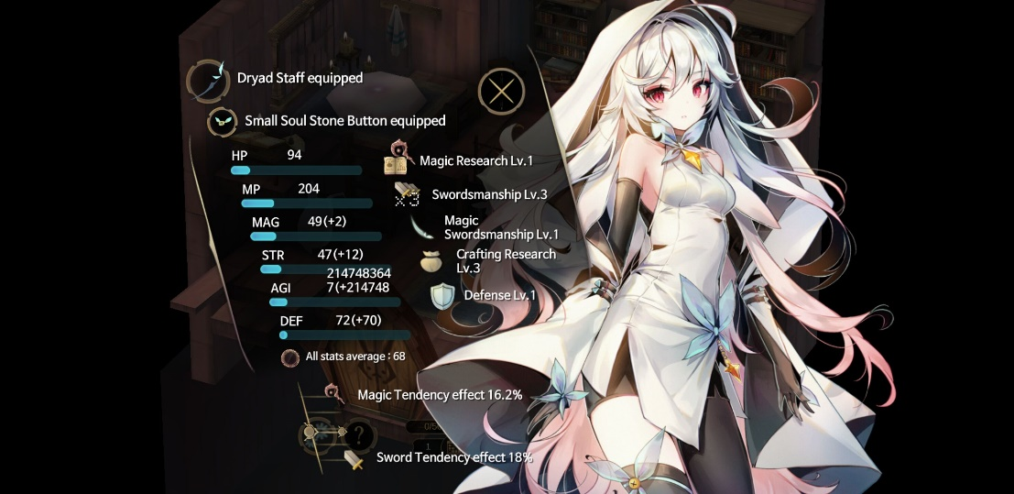
Figure 12 Statistics Design
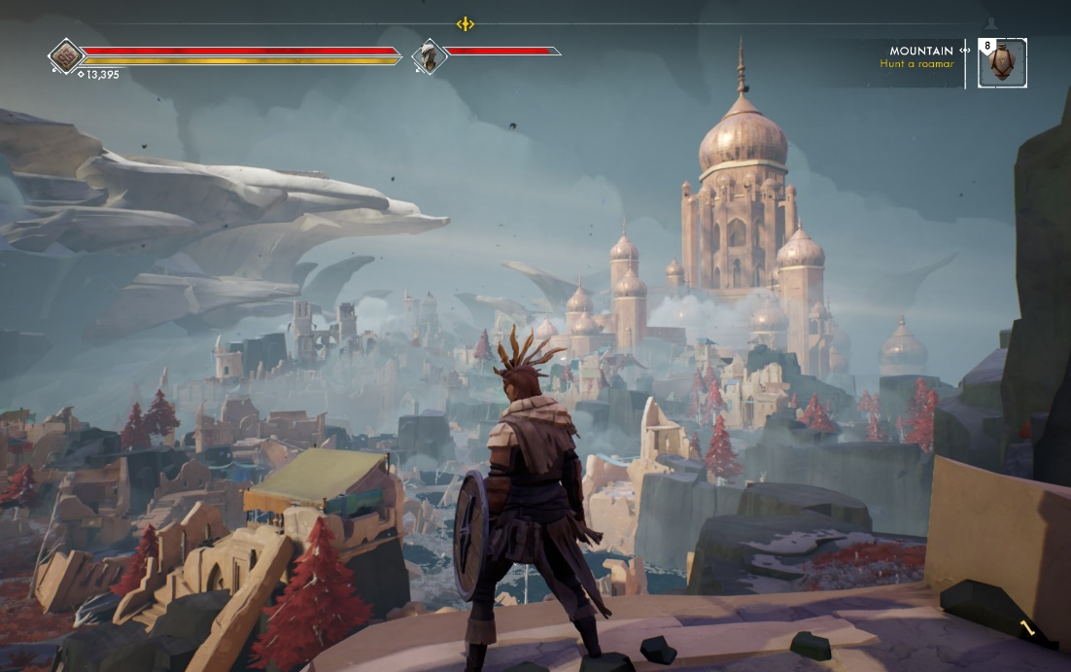
Figure 13 HUD Design (Health, Stamina etc.)

Figure 14 Soul Stone
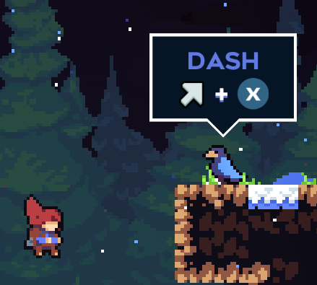
Figure 15 Interactive Tutorial Example

Screen Flow Design
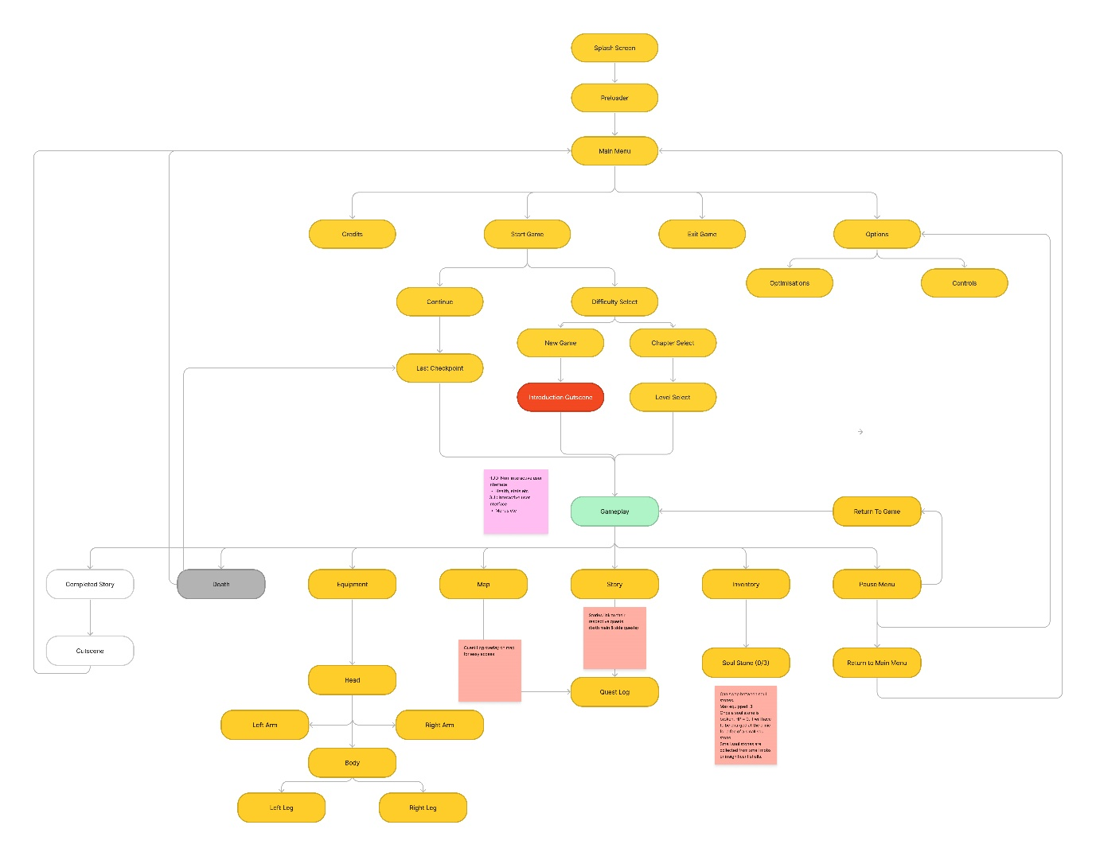

https://www.figma.com/file/nx3rxwNd46ejpKFYIQKdNP/Untitled?node-id=0%3A1&t=7t2PEasGayRPXGXp-1

References
All images are generated from the AI tool MIDJOURNEY: https://midjourney.com/home/?callbackUrl=%2Fapp%2F
Figure 7 Cybercity Concept Art 4: https://www.gamingonlinux.com/2019/07/sci-fi-point-and-click-adventure-encodya-now-has-a-demo-now-freely-available-on-itchio/
Figure 8 Statistics Design: https://witch-spring.fandom.com/wiki/Witch_Spring_3/Dolls
Figure 9 Inventory & Modifications UI Design: https://www.rockpapershotgun.com/assassins-creed-odyssey-inventory-how-to-get-the-best-weapons-legendary-armour-2
Figure 10 Tutorials given through a hologram UI: https://www.reddit.com/r/Warframe/comments/pz0s5d/i_think_i_found_the_dialogue_for_new_war/
Figure 11 Map Design: https://www.pinterest.com/daniel80barrett/scifi-maps/
Figure 13 HUD Design: https://techcrunch.com/wp-content/uploads/2018/12/ashen2.jpg
Figure 14 Soul Stone: https://witch-spring.fandom.com/wiki/Soul_Stone_(Eirudy)
Figure 15 Interactive Tutorial Example: https://www.gamedeveloper.com/design/methods-of-creating-invisible-tutorials
Screen Flow: https://www.figma.com/file/nx3rxwNd46ejpKFYIQKdNP/Untitled?node-id=0%3A1&t=7t2PEasGayRPXGXp-0

